  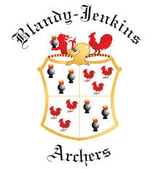 |  | Blandy-Jenkins Archers  May Metrics  UK Record Status - Junior Tournament (U21’s Only)  Rounds: Metric I-V only  Saturday May 16th 2026  @ Llanharan Welfare Grounds, Llanharan, CF72 9RA  Entry Closing Date: 8th May 2026 | Tournament Organiser  Simon Carter  17 Picton Gardens  Bridgend  CF31 3HH  blandyjenkins@gmail.com  Tel: 07981 816512
Lady Paramount: TBA
Judge in Charge: Adrian Gifkins (GWAS)
Tournament Fees | Entry Fee: £15  Payment is required at time of booking. Bank transfer is preferred to the Blandy Jenkins club account: Sort Code: 60–16–48 Account Number: 84050675  Add Reference “BJAMay26” and the last 4 digits of your AGB number to the payment as reference.  Any cheques to be made payable to “Blandy Jenkins Archers”  Please send the entry form or a photo/scan of your entry form to the organizer at the e-mail address above.  Please ensure you complete all boxes on the entry form.  Please note that we are not responsible for your children. You must have a parent or guardian present for the whole tournament.
Registration | Registration will be open from 07:30.  Archery GB Membership cards will be required for booking in. If you are not yet in possession of a valid card, please bring proof that you have paid your membership to your club.
Event Timings | All times are approximate
  Morning Session | Equipment Inspection: 08:30am  Assembly followed by one end of sighters: 9:00am  Shooting Commences: 9:30am
  Lunch | After two distance – approximately 12:30 to 13:00
  Raffle | 5:00
  Awards | 5:30
Shooting Rules | This is a UKRS Tournament. The tournament will be shot to the Archery GB rules in force at the time of the event.  Scoring will be via IANSEO paper sheets and will be double / duplicated for each boss.
Dress Regulations | Please refer to Archery GB’s rules of shooting for dress regulations (rule 307 will apply). Archers should comply with dress regulations until after the presentations.
Photography | In line with Archery GB policy, anyone wishing to take video or photographs during the event must register their details with tournament organiser. If parents/carers have any concerns about their child/young person being photographed or filmed, they should notify the organisers.  The organisers reserve the right to decline entry to any person unable to meet or abide by these conditions.
The Blandy-Jenkins field is a shared playing field; as such, lost arrows cannot remain unaccounted for. To minimise the risk of undetectable arrows being left on the sports field, archers are encouraged not to use all-carbon arrows. Archers wishing to use all-carbon arrows are required to indicate on the entry form, and to identify their equipment to the organisers at registration and also on departure. ALL ARROWS LOST MUST BE REPORTED AND FOUND.
The tournament organiser, Blandy-Jenkins Archers, and Llanharan Recreation Ground Trust cannot accept any responsibility for loss, damage or injury to persons, property or equipment before, during, or after this tournament, howsoever caused.

Rounds available | Note: The Open category is for male competitors and for those identifying as female but were not female at birth.  All faces are 10 zone scoring  First two distances are 6 arrows per end, last two distances are 3 arrows per end.
  Round Name | Age Group | Age | Category | Distances
  WA1440 (90m) | Under 21 | Aged 20 and under | Open | 90m/70m @122cm then 50m/30m @80cm
  Metric I | Under 21 | Aged 20 and under | Women | 70m/60m @122cm then 50m/30m @80cm
  Metric I | Under 18 | Aged 17 and Under | Open | 70m/60m @122cm then 50m/30m @80cm
  Metric II | Under 18 | Aged 17 and under | Women | 60m/50m @122cm then 40m/30m @ 80cm
  Metric II | Under 16 | Aged 15 and under | Open | 60m/50m @122cm then 40m/30m @ 80cm
  Metric III | Under 16 | Aged 15 and under | Women | 50m/40m @122cm then 30m/20m @80cm
  Metric III | Under 15 | Aged 14 and under | Open | 50m/40m @122cm then 30m/20m @80cm
  Metric III | Under 15 | Aged 14 and under | Women | 50m/40m @122cm then 30m/20m @80cm
  Metric IV | Under 14 | Aged 13 and under | Open | 40m/30m @122cm then 20m/10m @80cm
  Metric IV | Under 14 | Aged 13 and under | Women | 40m/30m @122cm then 20m/10m @80cm
  Metric V | Under 12 | Aged 12 and under | Open | 30m/20m @122cm then 15m/10m @ 80cm
  Metric V | Under 12 | Aged 11 and under | Women | 30m/20m @122cm then 15m/10m @ 80cm
Food | A variety of hot food, snacks and drinks will be available for breakfast and lunch.  Please bring your own mug for teas, coffees.

DIRECTIONS
What3Words: ///onion.paddocks.passion
GPS: 51.536841, -3.439469
Postcode: CF72 9RA
From Junction 34 on the M4
At the motorway roundabout, take the A4119 towards Llantrisant. At the next roundabout, turn left onto the A473 for Bridgend. Stay on the A473 following signs for Bridgend / Llanharan.
Once in Llanharan, the field is the 1st turning left over the railway bridge.
From Junction 35 on the M4
Follow signs for A473 North ‘Pencoed & Llantrisant’. Follow Pencoed by-pass (dual carriageway) to Pencoed College roundabout. From here follow signs for A473 Llantrisant or Talbot Green, until you come to Llanharan then follow the schematic below for shoot location
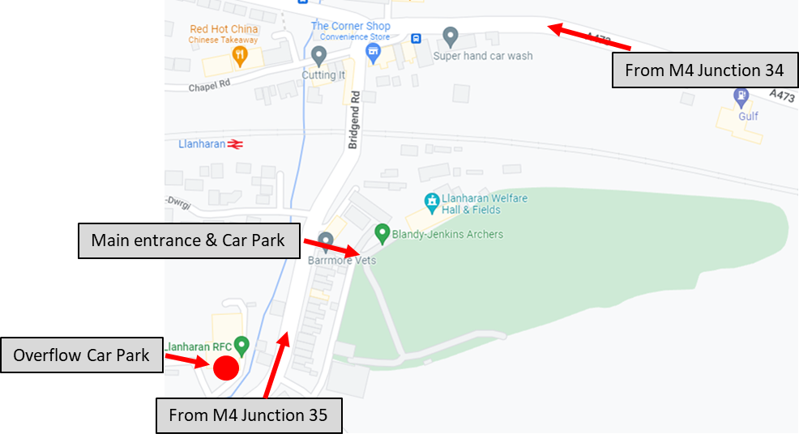
PARKING
There are plenty of parking spaces in 3 locations available to the shoot; two are on the grounds and the third 300yds away. There is limited space allocated for disabled archers/spectators please indicate on your application form if you require one of these spaces.
Cars are parked at owners’ risk.

GDPR
When you enter competitions, the following information may be collected and shared with tournament organisers, scoring systems, and other competitors. For example, target lists and results may be published: First Name, Surname, Gender, Bow style, Date of Birth / Age category, Email, Address, Phone number, Club (and ID), County (and ID), Region (and ID), Round (unless defined by age), Disabled (Y/N), Disability info.

Blandy Jenkins May Metric Tournament Entry Form  Saturday May 16th 2026  at Llanharan Welfare Grounds, Llanharan, CF72 9RA |  | 
Club: | Contact Address:
Total Payment: £ | Email (For target list and results):

Name | Archery GB Number | LH or RH | Bow Type | M/F | Age on 01/01/2026 | Round | Seated, VI or Other Requirement | Signature (Parent / Guardian if under 18) | Total Fee (£)
Bow types: Compound (CUL), Recurve (RC), Barebow (BB), and Longbow (LB)
Who | Question | Yes | No
Disabled Archers | Are you able to move on and off the line in the time allowed?
Disabled Archers | Do you intend to bring an assistant/agent?  NOTE – If you cannot bring an assistant/agent to assist you during the competition please contact the Tournament Organiser to discuss options. Unfortunately, it may not be possible to find a volunteer to assist Disabled Archers. Where possible please bring a carer or member of your family or household to collect your arrows and assist you during the tournament.
Able Bodied Archers | Are you prepared to collect arrows for disabled archers?
All Archers | Do any archers listed on this entry form intend to use all carbon arrows?
(Only photos, scans or prints of this page are required when entering)



PHOTOGRAPHY AND FILMING CONSENT FORM
(Copies will be available of this form on the day if required)
Organisation Name: | Blandy Jenkins Archers May Metrics 2026

In line with the recommendation in the Archery GB Safeguarding Children and Young People Policy, the promoters of this event request that any person wishing to engage in any video, zoom or close range photography should register their details with Event Organiser/Club Official at the spectator desk before carrying out any such photography.
If parents/carers have any particular concern about their child/young person being photographed or filmed they should notify the organisers
The promoter reserves the right to decline entry to any person unable to meet or abide by the promoter's conditions.
If you are concerned about any photography taking place at this event, please contact the Event Organiser/Club Official who will be pleased to discuss this matter with you.

Consent Information
To be completed by Parent/Carer :
□ | I consent to......................................................................(Parent / Guardian / Organisations Name)  Photographing/videoing ................................................................(my child/young person’s name)
□ | I have read/am aware of the Archery GB Guidance Document (SCG 05) Photographing/Videoing Children and Young People in Sport (A copy is available from the Tournament Organiser if required)
□ | I have read/am aware of how the organisation will use these images in future
To be completed by the Child/Young Person :
□ | I ..........................................................................................................(Child/young person’s Name)  consent to .....................................................................................................(Organisations Name)  Photographing/videoing my involvement in archery
□ | I have read/am aware of the Archery GB Guidance Document (SCG 05) Photographing/Videoing Children and Young People in Sport
□ | I have read/am aware of how the organisation will use these images in future

Child’s Name | Signature | Date
Parent’s Name | Signature | Date


Archery GB is the trading name of the Grand National Archery Society, a company limited by guarantee no. 1342150 Registered in England.
Archery GB Safeguarding Children and Young People Policy : SCF 05 Photography and Filming Consent Form – October 2014
This information will be stored as in line with the Data Protection Act 2018

